***Dt : 26/8/2022***

***Execution flow of above program:***

***ClassFiles:***

***UserDetails.class***

***UserRegistration.class***

***DisplayUserDetails.class***

***DemoMethods6.class(MainClass)***

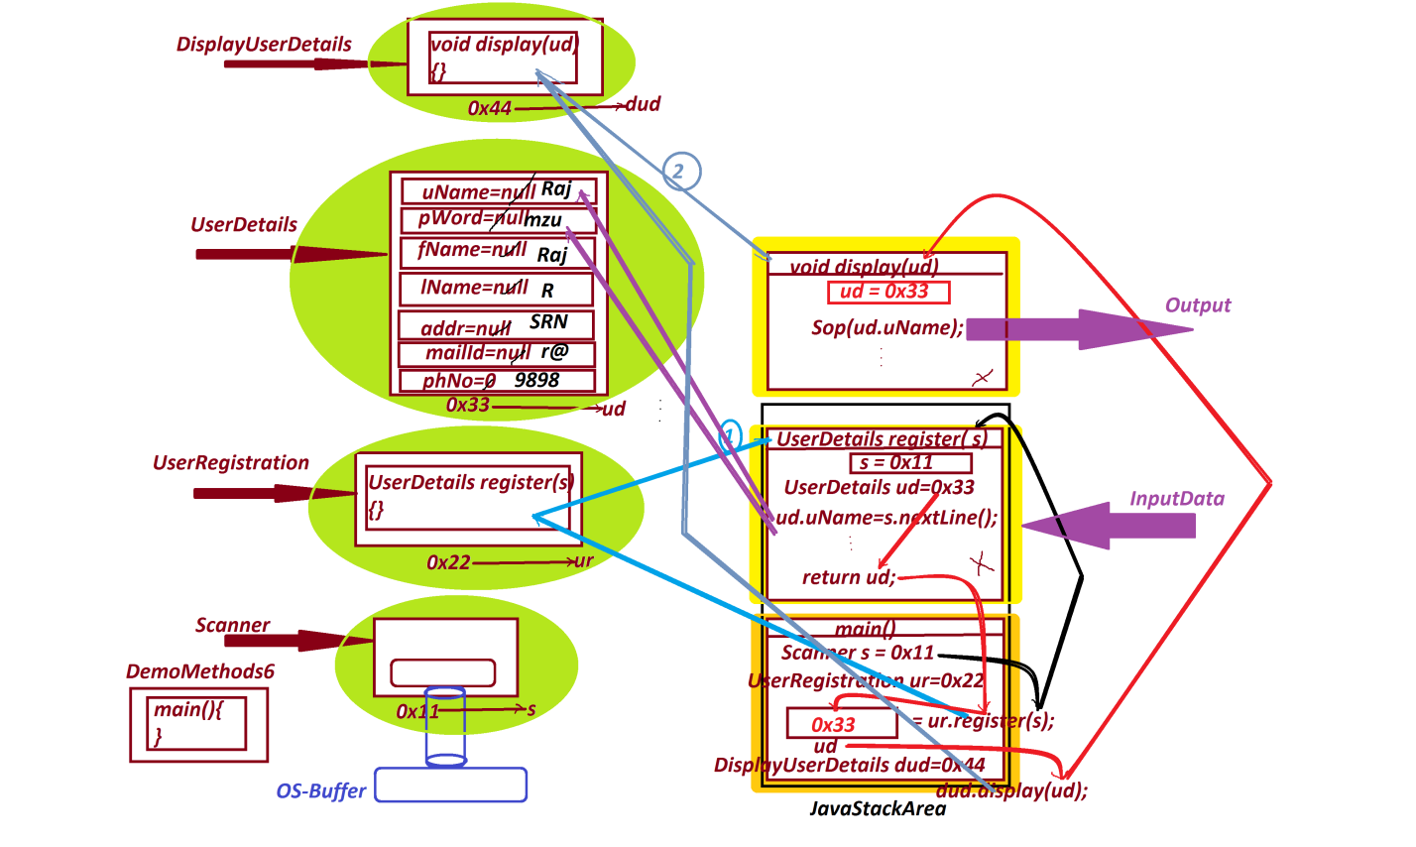

***===========================================================***

***Assignment:***

***wap to read and display Employee details using reference***

***variables as Parameter and returntype?***

***Layout:***

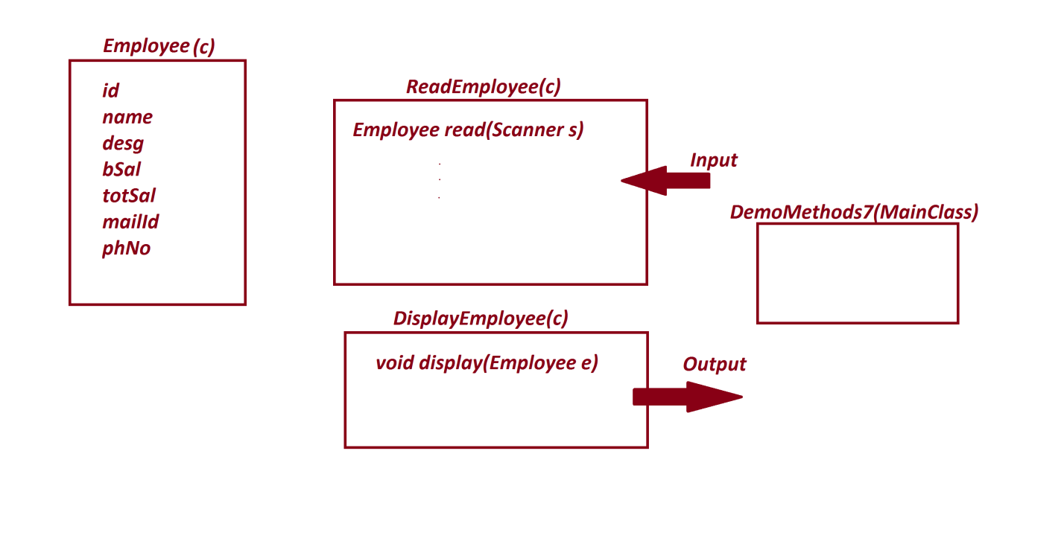

***=========================================================***

***faq:***

***wt is the diff b/w***

***(i)Object***

***(ii)Object Reference***

***(iii)Object Reference Variable***

***(i)Object:***

***=>The memory location where components are available is known***

***as Object.(Storage part is known as Object)***

***(ii)Object Reference:***

***=>The address where the object is created is known as Object***

***reference.***

***(iii)Object Reference Variable:***

***=>The variable which hold Object reference is known as Object***

***reference Variable.***

***Diagram:***

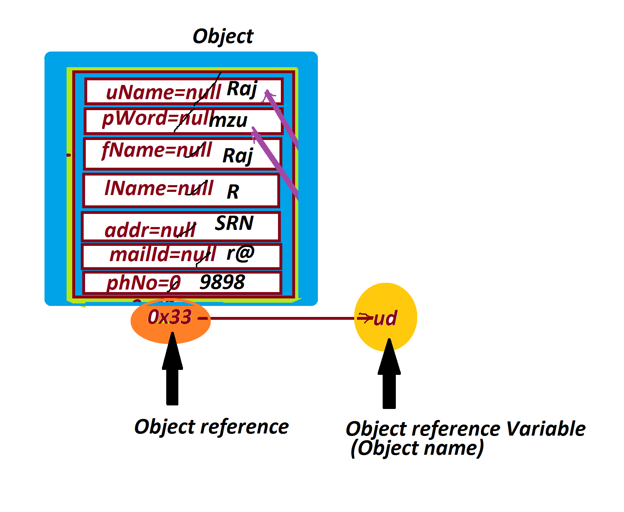

***=======================================================***

***\*imp***

***Blocks in Java:***

***=>The set-of-statements which are declared within the flower***

***brackets and executed automatically is known as block.***

***=>Blocks in Java are categorized into two types:***

***1.Static blocks***

***2.Non-Static blocks or Instance blocks***

***1.Static blocks:***

***=>The blocks which are declared with 'static' keyword are***

***known as Static blocks.***

***syntax:***

***static***

***{***

***//set-of-statements***

***}***

***behaviour:***

***=>Static blocks are executed only once when the class is used***

***for the first time.***

***=>Static blocks can access the static variables directly,but***

***cannot access Instance variables directly.***

***=>static blocks will have highest priority in execution than***

***static methods.***